6.4 Integrate JMeter with Jenkins

This section will guide you to:

* Configure JMeter with Jenkins.

This guide has five subsections, namely:

6.4.1 Install JMeter

6.4.2 Login to Jenkins

6.4.3 Add performance plugin

6.4.4 Create Jenkins job for JMeter

6.4.5 Push code to GitHub repositories

**Step 6.4.1:** Install JMeter

* Open your Linux terminal and run the below command to check if JDK is installed:

**java**

* Click the following URL to download the latest version of JMeter. You can download the binary or source file of this tool from this location. Click on the ‘**Apache-JMeter-5.0.zip’**link to download the binary zip file of JMeter.

[**http://jmeter.apache.org/download_jmeter.cgi**](http://jmeter.apache.org/download_jmeter.cgi)

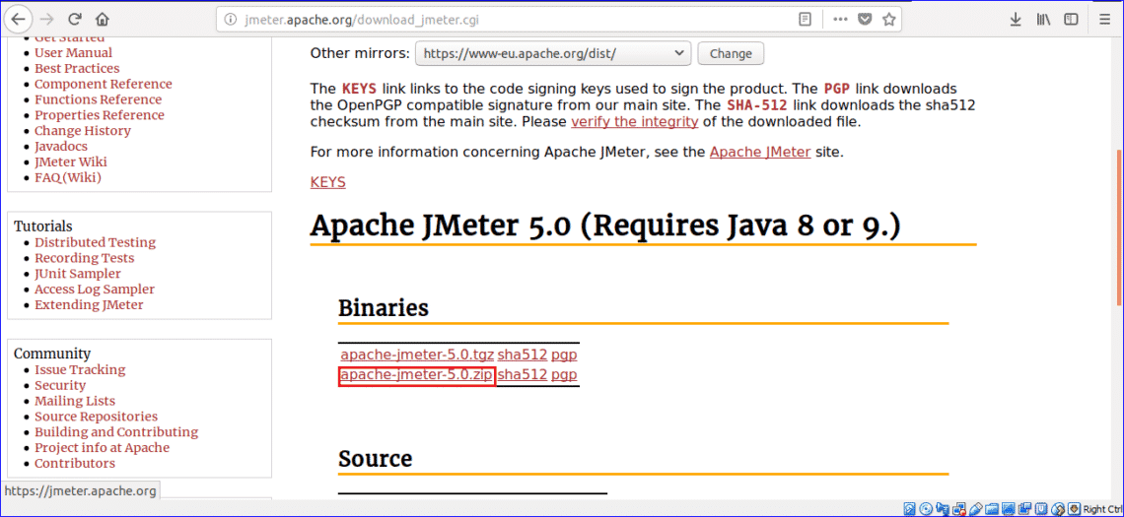

* The file will be downloaded in **the Downloads** folder. Open the folder, right-click on the zip file and click on **Extract Here** from the pop-up menu.
* Run the below command to run JMeter:

**$ cd Downloads/apache-jmeter-5.0/bin/./jmeter**

**Step 6.4.2:** Login to Jenkins

* Open your browser and navigate to **localhost:8081**
* Provide your username and password and click on **Login.**

**Step 6.4.3:** Add performance plugin

* Install the performance plugin via **Manage Jenkins -> Manage Plugins**.

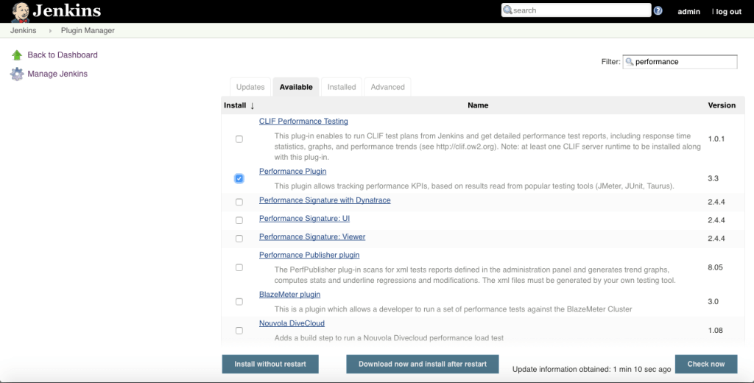

* Restart the instance.

**Step 6.4.4:** Create Jenkins job for JMeter

* Go to Jenkins home page and click on **Create New Job**, specify a name, select **Freestyle Project,** and click **OK**.

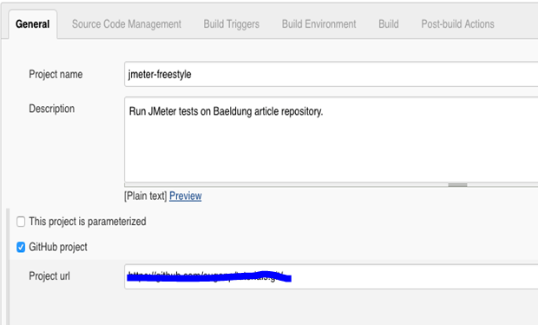

* Set the repository URL and branches to build:

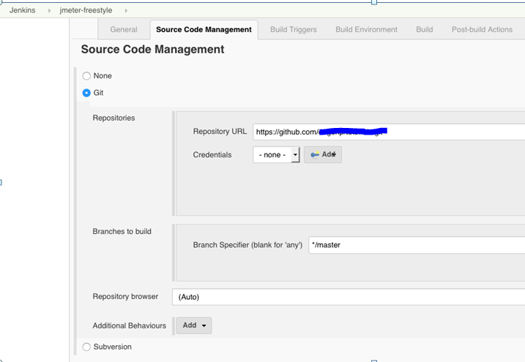

* Go to the Build Tab and on the Execute shellsub-tab, write a script to perform the necessary actions after the repository is cloned as shown below:

|  |  |
| --- | --- |
|  | **cd jmeter**  **./mvnw clean install -DskipTests**  **nohup ./mvnw spring-boot:run -Dserver.port=8989 &**    **while ! httping -qc1 http://localhost:8989 ; do sleep 1 ; done**    **jmeter -Jjmeter.save.saveservice.output_format=xml**  **-n -t src/main/resources/JMeter.jmx**  **-l src/main/resources/JMeter.jtl** |

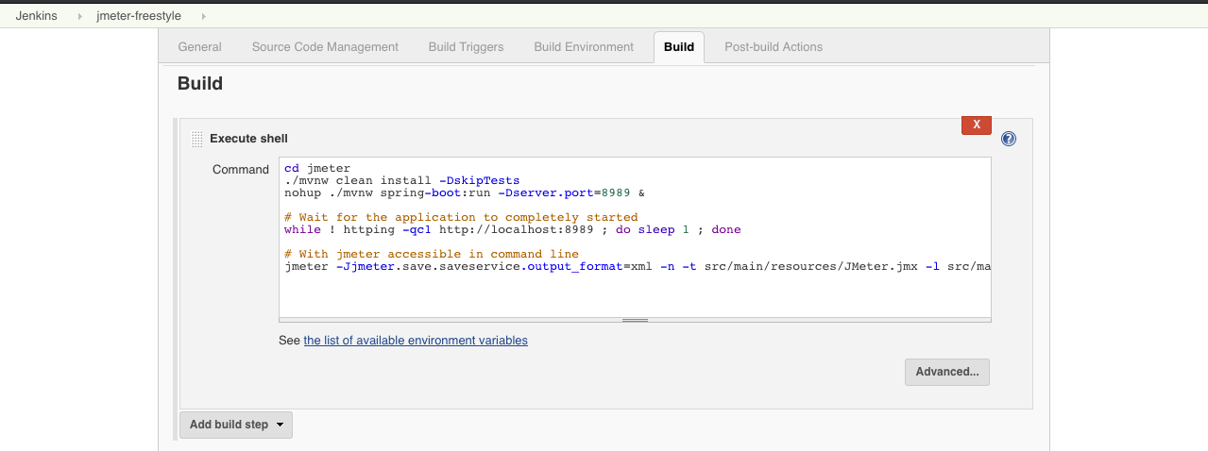

* Build the job.

**Step 6.4.5:** Push the code to your GitHub repositories

* Open your command prompt and navigate to the folder where you have created your files.

**cd <folder path>**

* Initialize your repository using the following command:

**git init**

* Add all the files to your Git repository using the following command:

**git add .**

* Commit the changes using the following command:

**git commit . -m “Changes have been committed.”**

* Push the files to the folder you initially created using the following command:

**git push -u origin master**